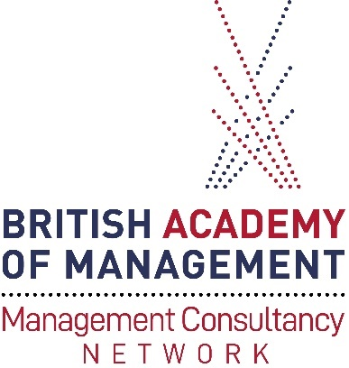

Annual General Meeting
31 August 2022 18:00 – 19:30
Conference
Alliance Manchester Business School and Online
Agenda
1 | Introduction and welcome
2 | The MCN story so far – report from the Co-chairs
3 | Treasurers report
4 | Updates to the MCN Committee
5 | Future events
6 | AOB
7 | Close

Management Consultancy Network Committee
- Calvert Markham – Co-chair
- Jeanette Hartley – Co-chair, Secretary
- Jim Johnston – Co-chair, Events
- Karol Szlichcinski – Treasurer
- Claire Brewis – Communications
- Simon Haslam – Publications
- Julie Hodges – Skills Development

