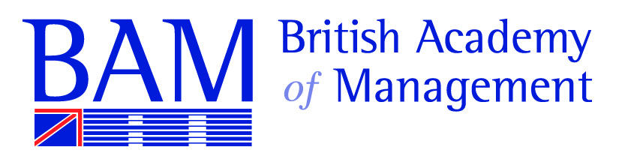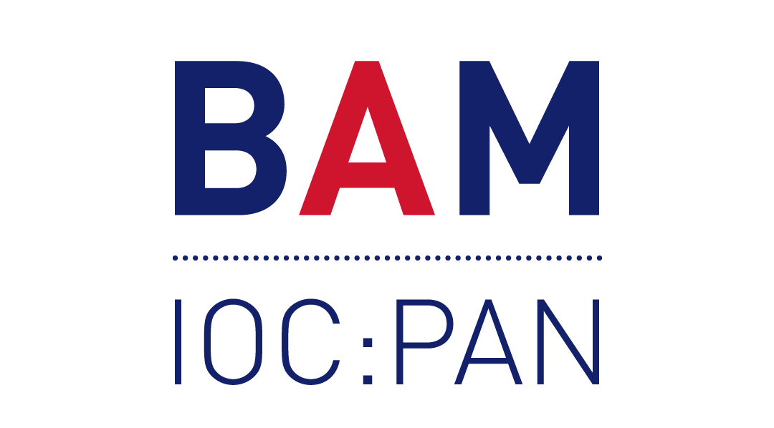

Invitation to the
Annual General Meeting
of
Inter-Organizational Collaboration: Partnerships, Alliances and Networks SIG

31.08.2022 18:00-19:30 (UK-time)
Online (Zoom) and face-to-face (Room to be confirmed)

Agenda:

- Welcome
- Apologies
- Minutes from 2021 AGM
- SIG Chair’s Report 2022
- Conference Track Chair Report
- Changes in Committee membership
- Election of SIG co-chair (2023-25)
- Election of PhD representative(s)
- Election of other committee member(s)
- Election of conference track chair 2023
- SIG Activities for 2022-2023
- Any other business

Reception (in-person) following the main business

